**BỘ GIÁO DỤC & ĐÀO TẠO**

**TRƯỜNG ĐẠI HỌC SƯ PHẠM KỸ THUẬT TP. HỒ CHÍ MINH**

**KHOA CHẤT LƯỢNG CAO**

**BỘ MÔN TỰ ĐỘNG ĐIỀU KHIỂN**

**-----------------⸙∆⸙-----------------**



**WEEKLY’S REPORT**

**TOPIC: SIMULATION OF FUZZY CONTROLLER**

**GVHD: Trần Đức Thiện**

**SVTH: Trần Minh Quân**

**MSSV: 19151078**

**Tp. Hồ Chí Minh 28 tháng 03 năm 2022**

Table of content

1. Temperature controlling 4

1.1 Requirement 4

1.2 Solution 4

2. Controling the DC motor speed 7

2.1 Creating the fuzzy system 7

2.1.1 Choose K3=240, K2=0. Vary K1 then survey the POT, settlling time, rise time and steady state error. 9

2.1.2 Choose K3=240, K1=1/100. Vary K2 then survey the POT, settlling time, rise time and steady state error. 11

2.1.3 Comment about the parameter K1 and K2 13

3. Exercise 13

**Table’s of figure**

Figure 1: Fuzzy logic controller system 5

Figure 2: Input Ti 5

Figure 3: Input To 6

Figure 4: Output Fan speed 6

Figure 5: Block diagram of controling the fan speed using fuzzy control 7

Figure 6: Result of the fan speed 7

Figure 7: Block diagram of the DC motor using fuzzy control to control 8

Figure 8: Input Error 8

Figure 9: Input Speed error 8

Figure 10: Output U 9

Figure 11: Block diagram of an DC motor using fuzzy control 9

Figure 12: Output of the system when K1 vary 10

Figure 13: Output at K1 when K1 vary 10

Figure 14: Error when K1 vary 10

Figure 15: Control signal when K1 vary 11

Figure 16: Output at K2 when K1 vary 11

Figure 17: Block diagram of DC motor when K2 vary 11

Figure 18: Output when K2 vary 12

Figure 19: Control signal when K2 vary 12

Figure 20: Error when k2 vary 12

Figure 21: Output K2 12

Figure 22: Fuzzy Logic Controller for heat furnace 14

Figure 23: Input Error 14

Figure 24: Input Error over time 15

Figure 25: Output temperature 15

Figure 26: Heat furnace graph 16

# Temperature controlling

## Requirement

To automatically control the air conditioner temperature using fuzzy logic, we used 2 sensor: In the room is a tempature sensor Ti and outside is a temperature sensor To. It will control the room temperature by controlling the fan speed. It given that:

- Temperature: [0oC – 50oC].

- Fan speed: v ∈ [0 – 600 vòng/phút].

- v: {Zero, Slow, Average, Fast, Max) corresponding with{0, 150, 300, 450, 600 rpm}

- Using input variable: Ti, To: {Very cold, Cold, Warm, Hot, Very hot} with the corresponding temperature{15,20,25,30,35}.

- Fan speed: {Zero, Slow, Average, Fast, Max}

Calculate the speed of the fan when: Ti=27oC ; To=32oC

|  |  |  |  |  |  |
| --- | --- | --- | --- | --- | --- |
| To  Ti | Very cold | Cold | Warm | Hot | Very hot |
| Very cold | Zero | Zero | Zero | Slow | Average |
| Cold | Zero | Slow | Slow | Average | Fast |
| Warm | Zero | Slow | Average | Fast | Max |
| Hot | Slow | Average | Fast | Fast | Max |
| Very hot | Average | Fast | Max | Max | Max |

## Solution

Create a fuzzy system that control the speed of the fan with input is the room temperature and the temperature outside and output is the fan speed.

Figure : Fuzzy logic controller system

* After that, we create the membership function for the 5 cases.

Figure : Input Ti

Figure : Input To

* Then we create the output Fan_speed.

Figure : Output Fan speed

Creating the model in simulink:

Figure : Block diagram of controling the fan speed using fuzzy control

Figure : Result of the fan speed

* Fan speed: 510 rpm

# Controling the DC motor speed

## Creating the fuzzy system

DC motor’s transfer function with no-load:



Motor with 3.7kW, 240V, 1750 rpm, parameter of the motor:

**

Figure : Block diagram of the DC motor using fuzzy control to control

Input of the error:

Figure : Input Error

Figure : Input Speed error

Figure : Output U

Fuzzy rule’s:

|  |  |  |  |  |  |  |
| --- | --- | --- | --- | --- | --- | --- |
| U(t) | | DE(t) | | | | |
| NB | NS | Z | PS | PB |
| E(t) | NB | NB | NB | NS | NS | Z |
| NS | NB | NS | NS | Z | PS |
| Z | NS | NS | Z | PS | PS |
| PS | NS | Z | PS | PS | PB |
| PB | Z | PS | PS | PB | PB |

### Choose K3=240, K2=0. Vary K1 then survey the POT, settlling time, rise time and steady state error.

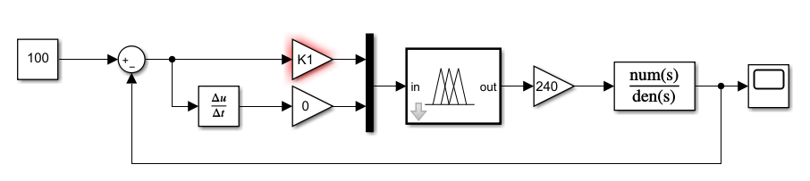

Figure : Block diagram of an DC motor using fuzzy control

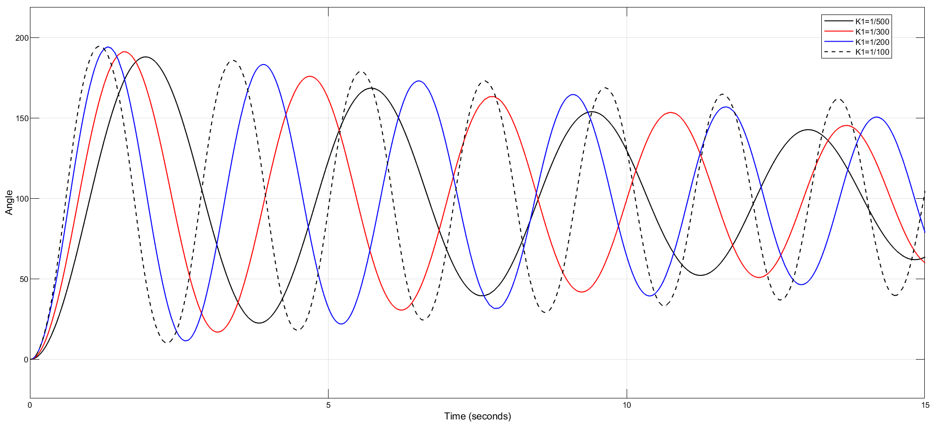

Figure : Output of the system when K1 vary

Figure :Output at K1 when K1 vary

Figure : Error when K1 vary

Figure : Control signal when K1 vary

Figure : Output at K2 when K1 vary

After simulation, the resulting output:

|  |  |  |  |  |
| --- | --- | --- | --- | --- |
| K1 | 1/500 | 1/300 | 1/200 | 1/100 |
| POT(%) | 88 | 91.13 | 94.26 | 94.88 |
| Ess | 0 | 0 | 0 | 0 |
| Tr | 0.626 | 0.528 | 0.52 | 0.451 |
| Tss | 102.3 | 102.29 | 102.27 | - |

### Choose K3=240, K1=1/100. Vary K2 then survey the POT, settlling time, rise time and steady state error.

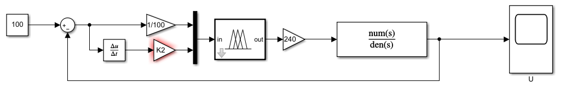

Figure : Block diagram of DC motor when K2 vary

Figure : Output when K2 vary

Figure : Control signal when K2 vary

Figure : Error when K2 vary

Figure : Output K2 when K2 vary

|  |  |  |  |  |
| --- | --- | --- | --- | --- |
| K2 | 1/300 | 1/200 | 1/100 | 1/50 |
| POT | 13 | 0.5 | 0 | 0 |
| Ess | 0 | 0 | 0 | 0 |
| Tr | 0.556 | 0.79 | 1.967 | 4.31 |
| Tss | 1.986 | 1.277 | 1.592 | 3.2 |

### Comment about the parameter K1 and K2

Parameter K1 is used to adjust the scale stitch. When increasing K1, the system will increase the overshoot, the rise time will decrease, the setting time will change slightly and the setting error will decrease.

Parameter K2 is used to adjust the system integral to increase overshoot, rise and fall time, constant steady-state error, and increase steady-state time.

# Exercise

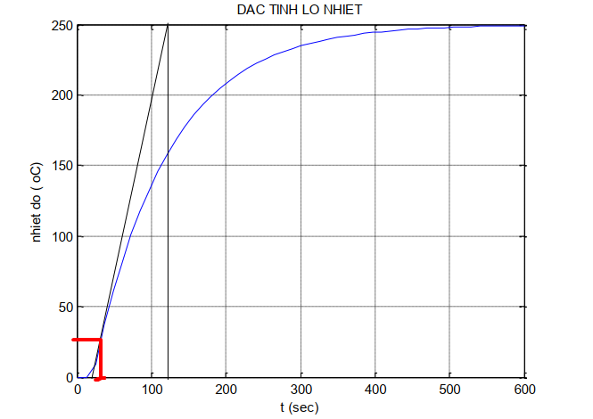

Figure : Characteristic of the heat furncace

With:

* T1 is a delay time
* T2 is a consant time
* T1=30
* T2=120

We have the transfer function:

|  |  |
| --- | --- |
|  | (0.2) |

Given:

Input is a step unit

Output is temperature of the heat furnace

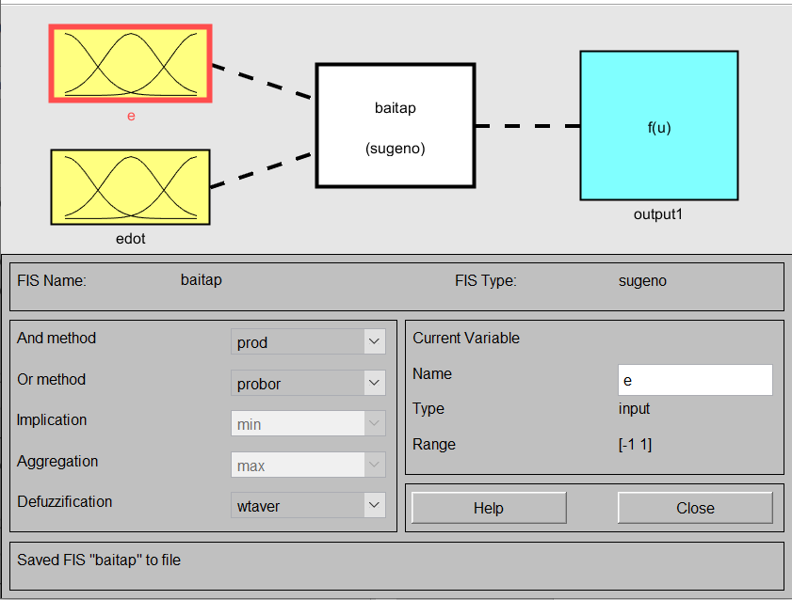

Figure : Fuzzy Logic Controller for heat furnace

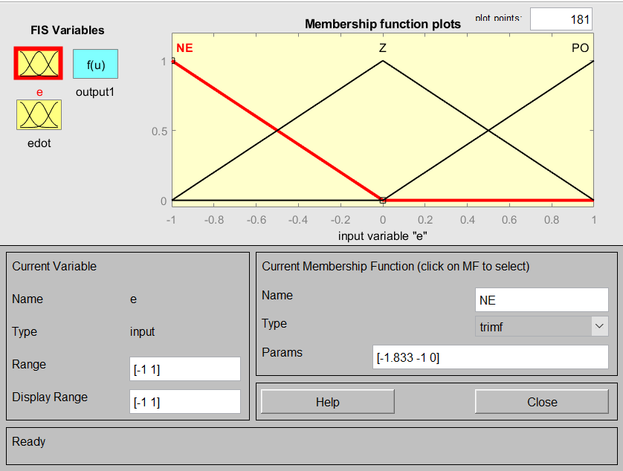

Figure : Input Error

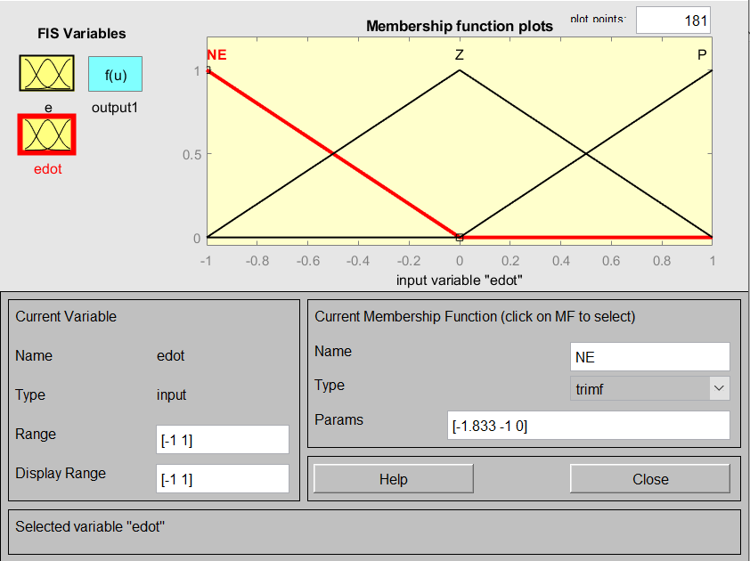

Figure : Input Error over time

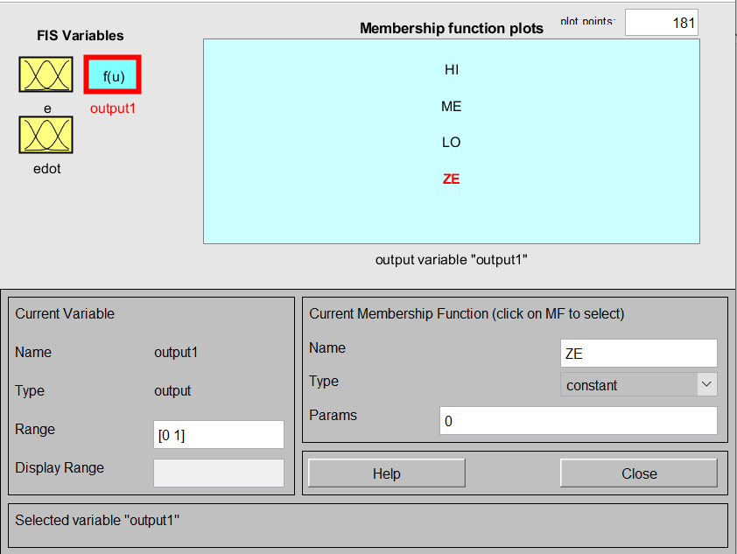

Figure :Output temperature

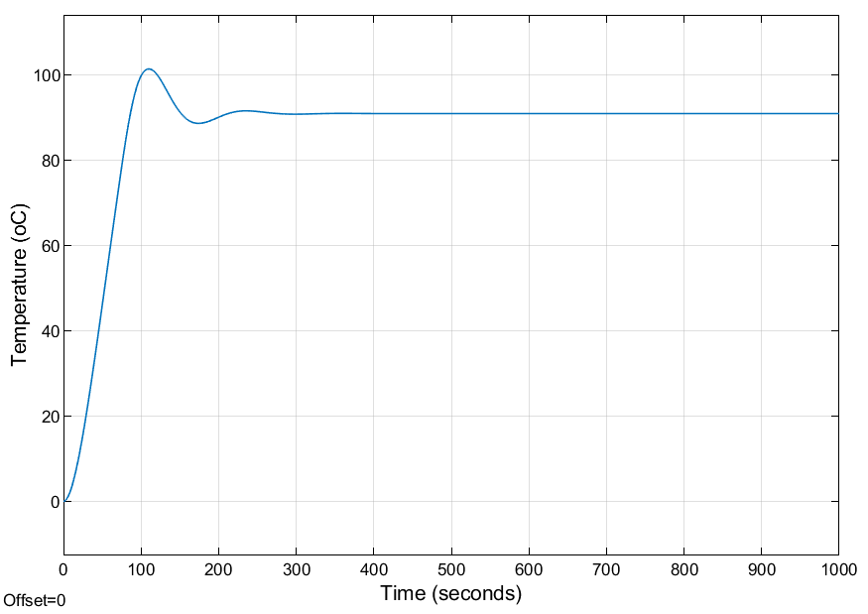

Figure : Heat furnace graph